Case Study 4: Examination Result

1. Problem Statement
Calculate a student's total marks, average, and result for three subjects.

2. Objectives
- Find total and average marks.
- Display pass or fail.

3. Assumptions
- Each subject is out of 100.
- A student passes if every subject mark is at least 35.

4. Algorithm
1. Read three subject marks.
2. Calculate total and average.
3. If every mark is at least 35, display Pass; otherwise, display Fail.
4. Display total and average.

5. Flowchart
START → Input three marks → Calculate total and average → Check every subject mark → Display result → STOP

6. Pseudocode
READ m1, m2, m3
total = m1 + m2 + m3
average = total / 3
IF m1 >= 35 AND m2 >= 35 AND m3 >= 35: DISPLAY Pass
ELSE: DISPLAY Fail

7. Python Source Code
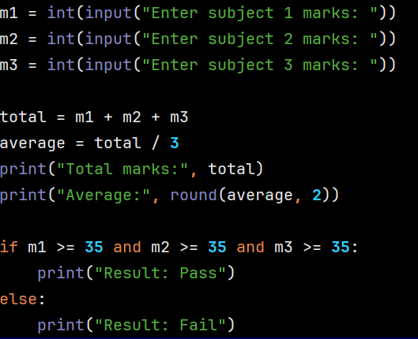

8. Test Cases
Test 1: 70, 60, 80 → Pass. Test 2: 70, 30, 80 → Fail.

Sample Output
Input: 70, 60, 80
Output: Total marks: 210
Average: 70.0
Result: Pass

9. Conclusion
The program calculates marks and uses a condition

